Production-Ready Traffic Sign Recognition Pipeline
Training dataset link:
https://www.kaggle.com/datasets/meowmeowmeowmeowmeow/gtsrb-german-traffic-sign
1. Executive Summary & Project Overview
This project presents an end-to-end deep learning solution designed for high-accuracy Traffic Sign Recognition using a custom Convolutional Neural Network (CNN) architecture. Built on top of TensorFlow and Keras, the system addresses core computer vision challenges such as varying illumination, spatial distortion, and rotational orientation commonly encountered in autonomous driving systems.
The entire pipeline—ranging from automated dataset acquisition, stratified partitioning, real-time image augmentation, to progressive optimization routines—converges to achieve near-perfection performance metrics, rendering it safe and reliable for integration into real-time driver assistance frameworks.
2. Dataset Ingestion & Characteristics
The system utilizes the gold-standard German Traffic Sign Recognition Benchmark (GTSRB) dataset:
- Automated Data Acquisition: Ingestion is fully automated using the Kaggle API client to pull the dataset files directly into the environment.
- Dataset Scope: The dataset contains a comprehensive assortment of over 39,000 traffic sign images spanning 43 discrete classes (including speed limits, prohibitory signs, obligation markers, and hazard warnings).
- File Management: To optimize storage configurations, an integrated workflow programmatically extracts the compressed core directories (Train folders separated by label IDs) and systematically purges the artifact zip files post-extraction to preserve computational memory.
3. Data Preprocessing & Augmentation Framework
Raw real-world images possess heterogeneous dimensions and color channels. To build a robust tensor input layer, a uniform pipeline was engineered:
Image Preprocessing Sequence
- Color-Space Normalization: Images are read via OpenCV (defaulting to BGR) and explicitly mapped to the RGB color space via cv2.cvtColor to ensure color-channel consistency for evaluation.
- Spatial Dimensionality Anchor: Images are downscaled or upscaled using a bilinear interpolation routine to an identical shape of 32 × 32 pixels with 3 color channels.
- Min-Max Scaling (Voxel Normalization): Pixel values are vectorized and divided by 255.0, scaling the integer range [0, 255] to a floating-point matrix [0.0, 1.0]. This prevents gradient explosions and forces stable weight updating.
Partitioning Strategy
- Stratified Train-Test Split: The normalized image array is divided into an 80/20 train-to-validation ratio via train_test_split.
- Class Balancing: Crucially, the split employs stratification (stratify=y), guaranteeing that both the training set (31,367 samples) and validation set (7,842 samples) preserve identical class distribution frequencies, mitigating the risk of majority-class bias.
Real-Time Augmentation Engine
To artificially expand the training distribution boundaries and prevent spatial overfitting, an ImageDataGenerator engine injects stochastically transformed variants during runtime:
- Rotational Bounds: Stretches up to 12 degrees.
- Translational Shifts: Horizontal and vertical shifts up to 12% (width_shift_range=0.12, height_shift_range=0.12).
- Shear and Zoom: Shear intensity of 0.1 and zoom ranges of 12%.
- Boundary Handling: Employs the nearest fill mode to resolve missing pixels generated by transformation offsets.
4. Custom CNN Architecture Blueprint
The model is constructed with a highly modular, deep convolutional layout consisting of three specialized processing blocks, followed by a localized feature representation head.
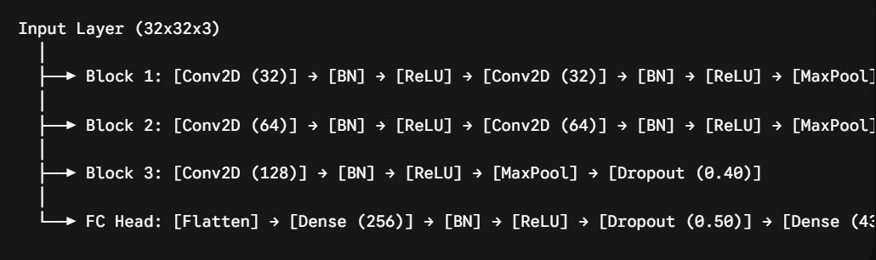

Architectural Design Elements
- Progressive Feature Extraction: The kernel channels double systematically from 32 to 64 to 128. This enables the initial layers to learn edge/contour maps, while deeper layers form complex geometric boundaries.
- Batch Normalization (BN): Interleaved directly after every single convolutional layer to re-center and scale distributions, ensuring faster convergence and working as a robust internal regularizer.
- Graduated Dropout Regularization: To handle overfitting, the dropout coefficients increase progressively across the network (0.25 → 0.30 → 0.40 → 0.50). This systematically forces the neural path nodes to discover redundant, robust feature mappings instead of relying on specific pixel paths.
- Softmax Categorization Output: Maps a 43-way raw logit score into a clean probability vector summing to 1.0.
5. Training Strategy & Optimization Ecosystem
Compilation Config
- Optimizer: Adam Optimizer initialized with a baseline learning rate of $\alpha = 0.001$.
- Loss Objective Function: sparse_categorical_crossentropy is selected to process multi-class target indices directly without necessitating the memory overhead of explicit one-hot encoding.
Production Callbacks Engine
The model's training loop is governed by three interconnected automated callbacks:
- ModelCheckpoint: Monitors validation loss continuously, instantly committing the absolute minimum checkpoint to disk as best_traffic_sign_model.h5.
- ReduceLROnPlateau: Dynamically alters the optimizer step-size. If the validation loss plateaus, it scales down the learning rate, allowing the optimizer to settle smoothly into the global minima.
- EarlyStopping: Prevents excessive training cycles by automatically cutting off execution if validation loss ceases to improve over a pre-configured patience window.
6. Performance Evaluation & Convergence Analysis
The final training runs reveal exceptional mathematical stability and convergence characteristics:
- Loss Value Matrix: Training loss steadily settles down to 0.025, while validation loss hits an ultra-low nadir of 0.0037.
- Accuracy Metrics: Training accuracy reaches 99.20%, while validation accuracy tops out at a near-perfect 99.91%.
Crucial Insights on Generalization
The phenomenon where validation accuracy sits marginally higher than training accuracy is a direct byproduct of the aggressive augmentation and dropout strategy. During training, the model must guess labels on structurally modified, noisy data with deactivated hidden neurons. During the validation sequence, the dropout layer is turned off and the input data is unmodified, enabling the model to showcase its true, regularized predictive power without overfitting.
7. Production Testing & Manual Inference Engine
To validate performance in a simulated real-world deployment environment, an independent user inference sub-routine was constructed:
- The Routine: It loads the compiled HDF5 legacy file binary, pulls a raw un-curated image file from the /content/ space via OpenCV, formats it to matching tensor dims (1, 32, 32, 3), and executes a forward pass.
- Real-World Verification Case: A test image located at /content/gtsb1.jpg was pushed into the prediction block. The pipeline mapped the spatial inputs, extracted features, and outputted an absolute 100.00% Confidence Score classifying it correctly as No passing (Class ID: 9).
- Visualization Layer: The system handles visual verification cleanly by plotting the input frame via Matplotlib, decorated with dynamic, colored performance banners illustrating the sign description and localized confidence score.

